CRUISE: TRAINING EXPERIENCE
1) THE CRUISE LINER: was very luxurious, clean and perfect from very point of view. On board you could find all kinds of fun and entertainment such as a disco, game room (like laser games), relax room, a bookstore, various types of bars with live music, and even a small church. The cruise liner had two wonderful restaurants.

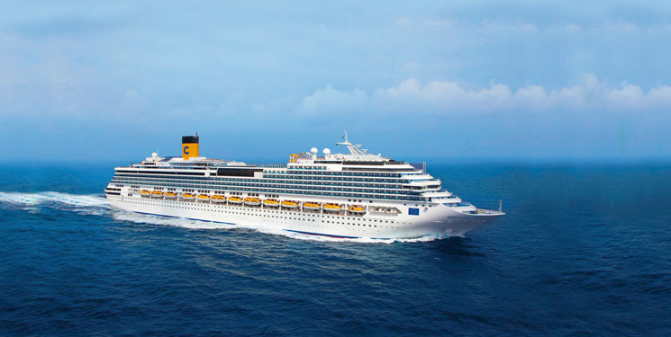

2) WORK PLACEMENT: during the cruise we had the opportunity to work for a few hours with the cruise receptionists. The work on board is very different from that of a hotel reception, they don’t check-in or check-out guests but they help and assist the customers. The girls assisting the guests are very young, between 20 end 25 years old, they can speak so well at least three languages that are usually English, Italian, French, many also speak Russian, German, and Spanish. We only worked 4 hours but we were able to understand the important aspects of this works.
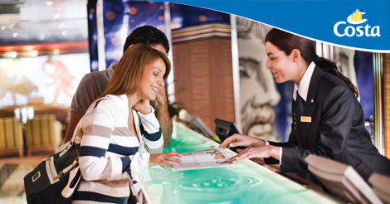

3) FREE TIME: we didn’t have much free time beacause every day we had a different city ti visit but on the cruise there were very different attractions and distractions, for the children there was always some kind of entertainment, music and group dance. For the adoults disco, bar, library and games room, a whole room for slot machines. In the evening there was always a themed party and it was a lot of fun to participate.

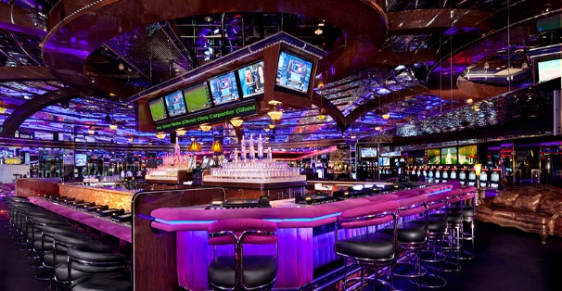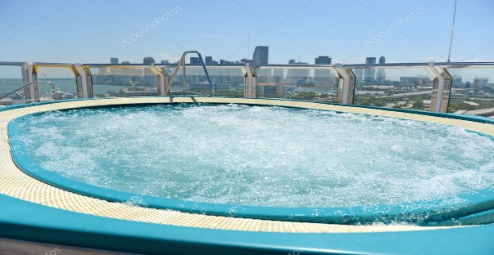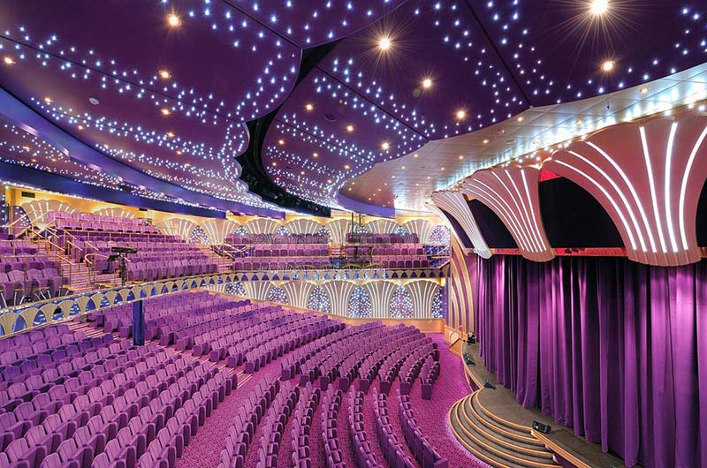

4) THE CITIES:
the ports of call are:
Savona
Marsillia
Barcellona
Palma di Maiorca
Palermo
Roma
We left from the port of Savona arriving about 8ò clock the next morning in Marseille, France. There we saw a beautiful cathedral and in the afternoon we went back on the cruise liner. The second day we saw Barcellona: the Sagrada Familia, la Rambla, casa Battlò, casa Milà, Plaza Cataluya and the market ‘’ la Boqueria’’. On the third day we saw Palma de Mallorca and its fantastic cathedral. After Palma we visited Palermo with its theatre Massimo, the Pretoria square, Normans Palace and the market ‘’Ballarò’’. On the last day we visited Rome, the colosseum, Venezia square anc the Trevi fountain

.