USA NATIONAL PARK
Paolini-Pace
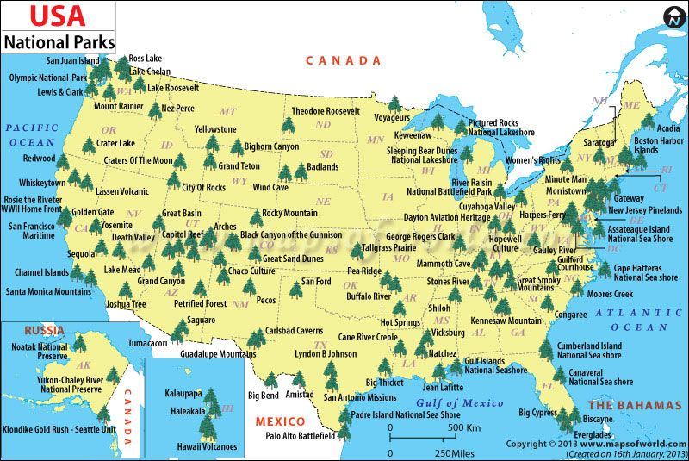

1 DAY: journey
2 DAY: Capitol Reef National Park
Capitol Reef National Park is one of the national parks in the United States, located in southern Utah. It extends for over 160 km, but has a rather narrow conformation. The park, founded in 1971, has a width of 979 km² and is open to visitors throughout the year.
Activities:
Auto Touring: There are three districts which can be explored by vehicle. Both paved and off road options allow exploration of this highly scenic area.
Biking: Bicycles must remain on maintained roads open to vehicular traffic. A handout available at the visitor center identifies and describes recommended routes.
Camping: With one developed campground, two primitive campgrounds, and vast backcountry options there are many places to stay the night in the park.
Explore Fruita: Listed on the National Register of Historic Places, the district includes the one-room Fruita Schoolhouse, Gifford House Store and Museum, Merin-Smith Blacksmith Shop, orchards, and a picnic area with tables under shade trees.
For Kids :Kids of all ages can participate in the park's Junior Ranger Program. Booklets are available at the visitor center or online. Other activities may be available during the summer season.
Hiking: Great hiking options exist from one hour overlook trails to multi-day backpacking in remote areas of the park.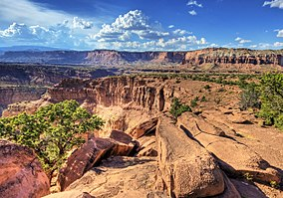 Duration of the stay: 2 days
3-Bryce Canyon National Park
(from capitol reef national park take 2 h and 7 min by car)
Bryce Canyon National Park is a small national park located in the southwestern United States in the state of Utah. The protected area includes the famous Bryce Canyon which, despite its name, is not really a canyon but a huge amphitheater originating from the erosion of the eastern sector of the Paunsaugunt Plateau
THINGS TO DO IN BRYCE CANYON NATIONAL PARK
Visit Bryce Point.
Get inspired at Inspiration Point.
Hike the Navajo Loop Trail.
See the Natural Bridge.
Views from Agua Canyon.
Stop at Rainbow Point.
Join a night hike with their Ranger Program.
Hike the Peek-A-Boo Trail.
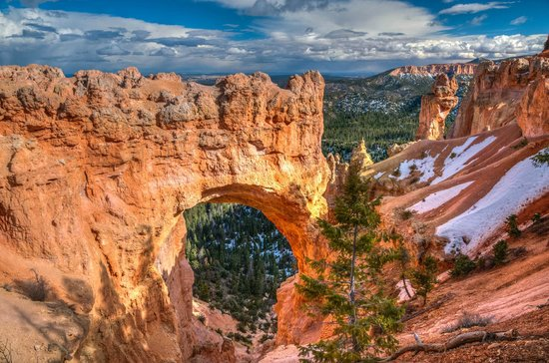 Duration of the stay: 2 days

4- Zion National Park (1.21 H)
Zion National Park is a fascinating natural park, characterized by a deep gorge carved by the Virgin river, a wide and truly breathtaking canyon with cliffs that drop to a peak for about 3,000 meters. Characteristic are the bright red and white colors and the incredible sculpted rocks that flank the hanging valleys.
Activities
-Backpacking : Get trail and campsite descriptions and conditions, and find out how to obtain a backpacking permit in Zion.
-Bicycling: The Pa'rus Trail and Zion Canyon Scenic Drive are accessible to bicycles. The shuttles have bike racks.
-Birding: Zion is home to 291 species of birds. Bird checklists are available at the visitor centers
-Camping : Zion has three campgrounds. Watchman Campground takes reservations from March through late November.
-Canyoneering: Learn about canyoneering in Zion and how to obtain a permit.
-Climbing: Find out about climbing in Zion and how to obtain a permit for overnight bivouacs.

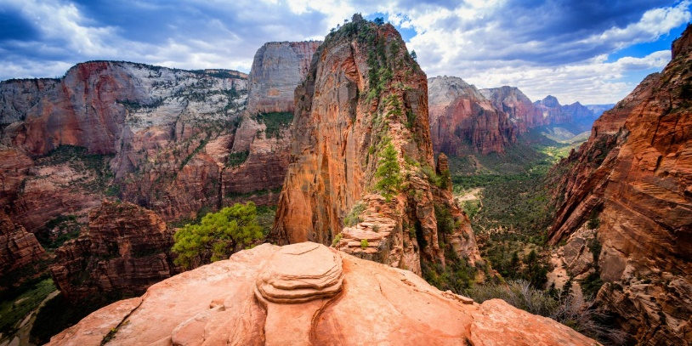 Duration of the stay: 1 day
5- Grand Canyon National Park (3.30 h)
In the Grand Canyon National Park, Arizona, lies most of the immense Grand Canyon, with its red rock strata revealing millions of years of geological history. Observation points are Mather Point, Yavapai Observation Station, Lookout Studio and Desert View Watchtower
Activities:
Grand Canyon South Rim Look-out Points
Grand Canyon South Rim Historic Sites – There are several historic sites at the South Rim that are worth seeing. For more historic “must-sees” click here.
National Geographic Grand Canyon Visitor Center & Grand Canyon IMAX Theatre –
Canyon View Information Center Information Center – Another great information center is the National Park Visitor Center located at Mather’s Point in the Park.
Bright Angel Bicycle Rentals – There a many outlooks over the Canyon that cannot be accessed by car but you can bike to these unique viewpoints

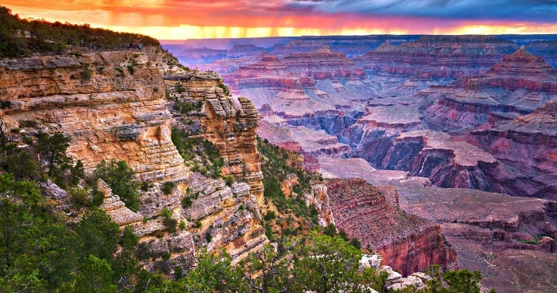 Duration of the stay: 2 days and half
6- RELAXING DAY

7- Petrified Forest National Park (2.50 h)
is an American national park in the Navajo and Apache counties in northeastern Arizona. Named for its large petrified wood deposits, the park's paid area covers about 230 square miles (600 square kilometers), including semi-hard steppe of highly eroded and colored shrubs and gullies.
Stay from 10.00 to 18.30
Activities:
It has a library, exhibits, a restaurant open from 8:00 am to 3:00 pm, a gift shop, a service station, a post office open from 11am to 1pm Monday to Friday, a mailbox and public toilets . The Rainbow Forest Museum, located 2 miles north of the park's south entrance, offers services that include information and "Timeless Impressions" shows once every half hour
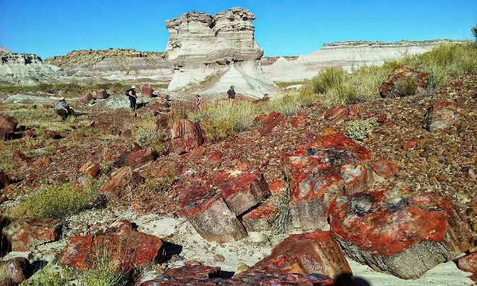 Duration of the stay: 1 day

8- Mesa verde national park (4 H AND 4 MIN)
The Mesa Verde National Park is a protected natural area of ​​the United States and a UNESCO World Heritage Site. It is located in the state of Colorado, in the county of Montezuma.
Activities:
Guided tours are the only way to see up close the fascinating cave dwellings of Mesa Verde:
Cliff Palace, the largest cliff dwellings complex in the world, I recommend you don't miss it!
Balcony House requires a very demanding tour with steep climbs and narrow tunnels (not recommended for those who suffer from vertigo)
Long House (on Wetherill Mesa). The settlement built in the largest cave. You can get there with the shuttle service and take about sixty steps.
Spruce Tree House, the only house open even in winter, a small village of 3-story structures set in the usual rocky recess.
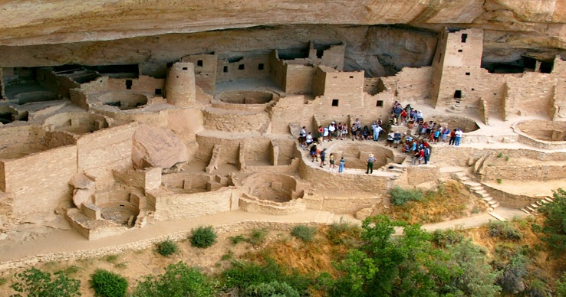 Duration of the stay: 1 day

9- Great sand dunes national park ( 4 H AND 34 MIN)
The Great Sand Dunes National Park and Preserve is a national park located in Colorado, in the United States of America.
Activities:
Start your day at The Great Sand Dunes with a visit to the visitor center to watch a film about the history of the dunes, see the exhibits showing the uformation of the great sand dunes, and get a lay of land from the local park rangers. We advise you to chenique ck the dune field from the main parking area of ​​Dunes, where you can explore Medano Creek, slip into the sand for the dunes or start planning a 4x4 tour through the dunes
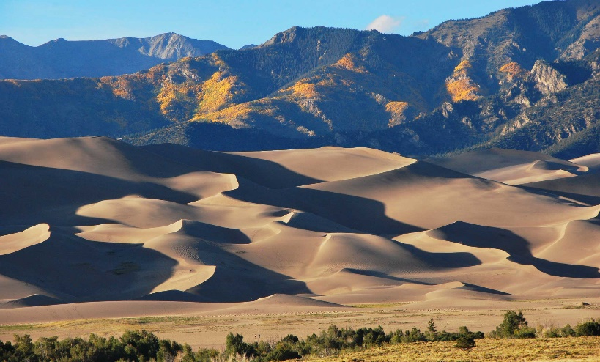 Duration of the stay: 2 days

9-Rocky Mountain National Park ( 2 H and 16 min)
Endowed with majestic mountains, rich wildlife, lakes and streams (including the Colorado springs), different climates and environments such as forests, mountain forests and the tundra.
The highest point of the park is Longs Peak, 4.346 m.s.l.m., by the explorer Stephen H. Long who, in 1820, led a long expedition in that territory.
It is divided by the Continental Divide, the watershed that separates North America between the basin of rivers that end in the Atlantic Ocean and those that end in the Pacific Ocean, which gives the two parts of the park different characteristics, in fact the eastern side tends to be drier and with many icy peaks, while the western one is more humid and lush, dominated by dense forests.
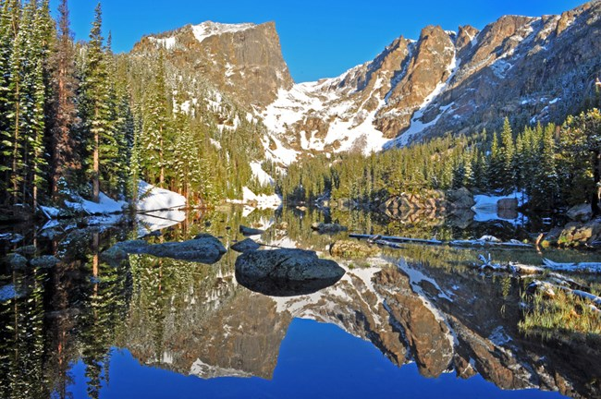 Duration of the stay: 1 day

