Study holiday Pace Rebecca
Where/location: London
The period: 6 weeks
Language course: English
Work placement: zero hours
Number of lessons: 20 lessons (standard) 45 minutes for lessons
Number of hours: 170 hours
Number of students per class: 21 people
Social activities: A ticket to the theatre or musical: £15-£ 30
A day show/excursion to London: £10
An entire day of sightseeing outside of London: £30
A night in a London club: £10 at the entrance
Brunch at a restaurant around the school: £5-£12
Traditional Afternoon tea: £8-£ 15
Tour with the visit to the places of Jack the Ripper: £5
Accommodation:
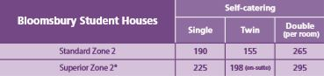
*Private bathroom can be arranged for a supplement of £30 per week, subject to availability.

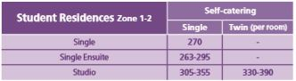

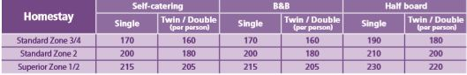
En-suite/private bathroom can be arranged for an additional fee, subject to availability. Full board option available upon request, prices from £195 per week.

Minimum booking: 1 week
Arrival day: Sunday
Departure day: Saturday
Minimum age: 18 (except for homestay)
Twin rooms: Only available for two people travelling together (except for Bloomsbury Student Houses).
Additional charges applicable to arrivals at unsociable hours, extra night stays and guests/visitors.

